1 Website Setup

Contents

Adding the folders to XAMP 1

Create the index.html 3

Give your webpage a title 4

Add your Style sheet 4

Starting to write out the code for the body - Header 4

Body Code Main Section 6

Adding Social Icons 7

The Footer 8

Font Awesome 9



# Adding the folders to XAMP

Start out by starting a new folder in XAMP



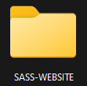

In this folder, you want to create a folder

1. A dist folder

Inside of the dist folder you will be adding the img folder, latter we will also be adding the CSS to the dist folder and the js, and the html files. Your scss folder is outside of the dist folder

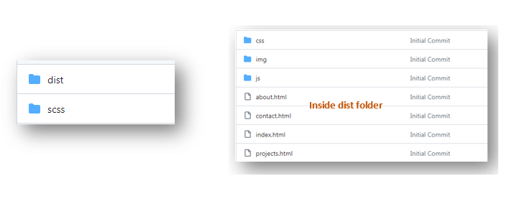

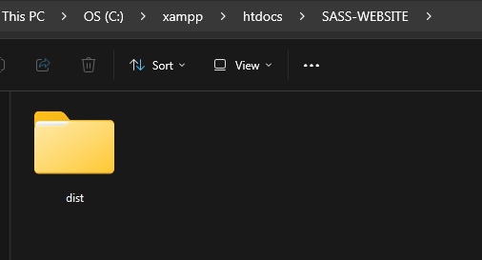

Inside the dist folder

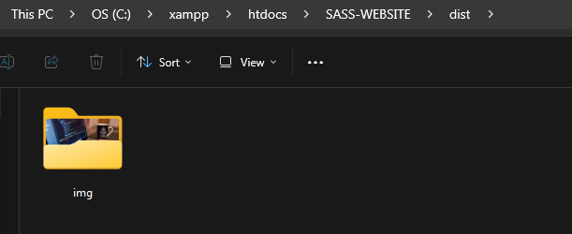

You will need 7 images all of this size

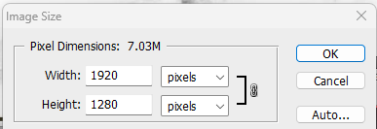

Go to Visual Studio Code

# Create the index.html

Still inside of the dist folder create your index.html

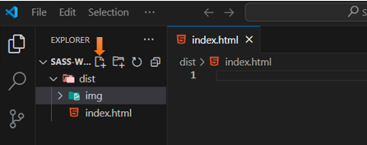

Using Emmet, we can use the shortcut of

! and Enter

<!DOCTYPE html>

<html lang="en">

<head>

<meta charset="UTF-8">

<meta name="viewport" content="width=device-width, initial-scale=1.0">

<title>Document</title>

</head>

<body>

</body>

</html>

# Give your webpage a title

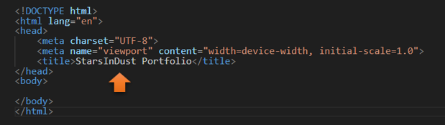

# Add your Style sheet

Add your Style sheet, now even though we will be writing our code in SASS, browsers can only interpret CSS, so the link to this page actually needs to be to the CSS page that will be created by SASS. Now even though this has not been created yet, we at least will have a link to it, when it is.

<link rel="stylesheet" href="css/main.css"

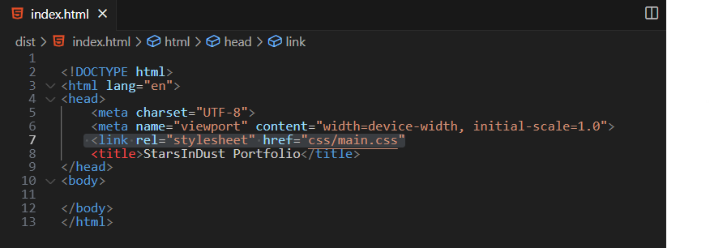

# Starting to write out the code for the body - Header

We will be starting out with a header tag. To make things easier, we can take the home li and use an Emmet shortcut of:

shift-alt-down arrow

That will duplicate the code and then we can just customize it to work with each page we want to link to.

<header>

<div class="menu-btn">

<span class="menu-btn__burger"></span>

</div>

<nav class="nav">

<ul class="menu-nav">

<li class="menu-nav__item active">

<a href="index.html" class="menu-nav__link">Home</a>

<li class="menu-nav__item">

<a href="about.html" class="menu-nav__link">About Me</a>

<li class="menu-nav__item">

<a href="projects.html" class="menu-nav__link">My Projects</a>

<li class="menu-nav__item">

<a href="contact.html" class="menu-nav__link">Contact Me</a>

</li>

</ul>

</nav>

</header>

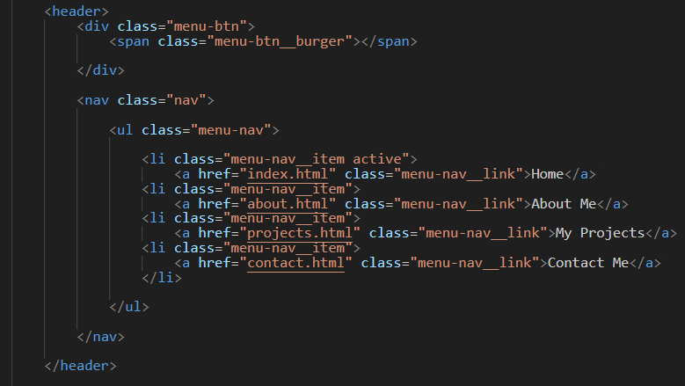

# Body Code Main Section

<main>

<section class="home">

<h2>Welcome to my Portfolio Site</h2>

<h1 class="home__name">My name is: <span class ="home__name—

last">StarsInDust</span></h1>

<h2>

Web Developer, Designer & Programer

</h2>

</section>

</main>

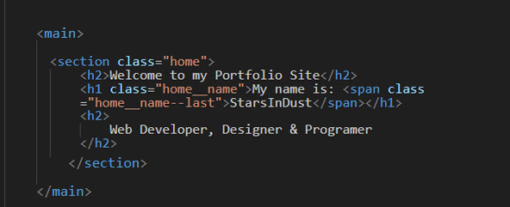

# Adding Social Icons

We will be placing these social icons, inside of the same section tag as our <h1> and <h2> tags.

We will be using font awesome for this, and I will show you how to set that up to use that in just one minute.

You will want to wrap each individual social icon in its own a href tag.

<section class="home">

<h2>Welcome to My Portfolio Website</h2>

<h1 class="home__name">StarsInDust</h1>

<h2>

Web Developer, Designer & Programer

</h2>

<div class="social-icons">

<div class="social-icons">

<a href="#!"><i class="fab fa-twitter fa-2x"></i></a>

<a href="#!"> <i class="fab fa-facebook fa-2x"></i></a>

<a href="#!"><i class="fab fa-instagram fa-2x"></i></a>

<a href="#!"><i class="fab fa-github fa-2x"></i></a>

</div>

</div>

</section>

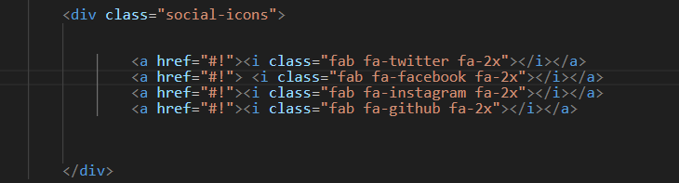

# The Footer

This is still going to be within that same <section> tag

<footer>&copy; Copyright 2024</footer>

Set this before the closing </section> tag

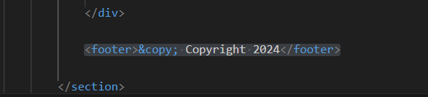

Now in order for that year to be able to change we will be needing to attach a JavaScript file. So, we will start out by adding the script to this page so it can be found. We have not written the JavaScript code yet, so do not expect things to work just yet.

<script src="js/main.js"></script>

This code will be placed after the </main> closing tag, but before the closing </body> tag

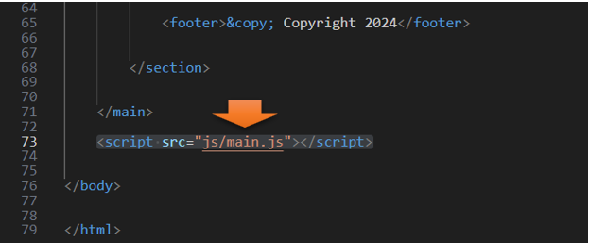

# Font Awesome

<https://fontawesome.com>

You will need to sign up for a free account

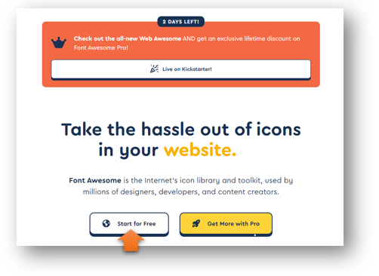

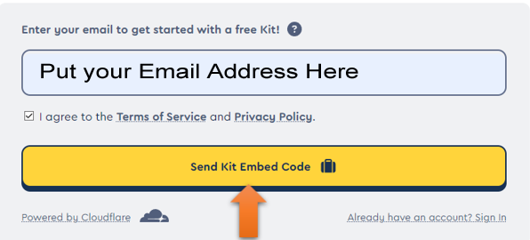

Click on the button that says free

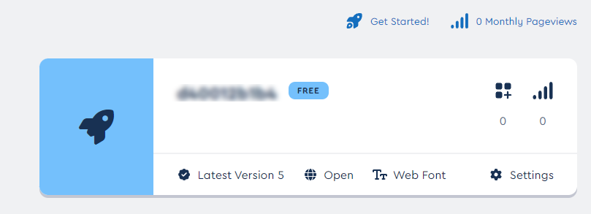

Click the copy button at the end of this script tag

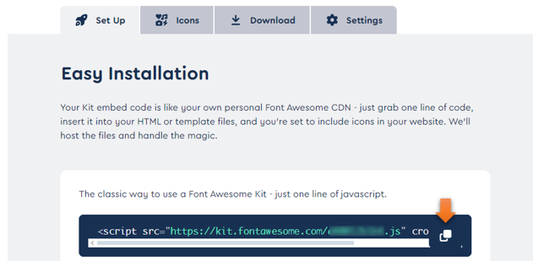

You will want to place that in the code here right above the other script tag, and right before your body tag.

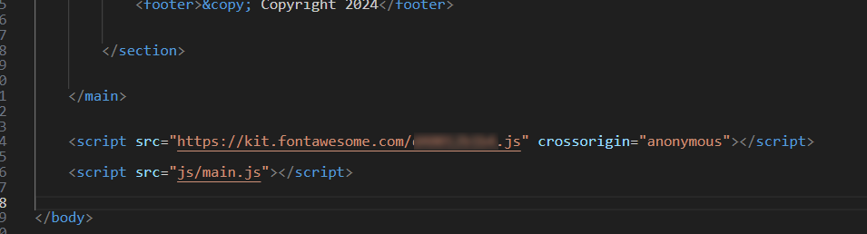

If you test it now, it will look a mess with no styles, but your font awesome icons should be showing up

